Theme development
Theme unit test: this is the dummy data xml file used for dummy data

Important templates
- header.php
- footer.php
- index.php
- single.php
- page.php
- home.php
- archive.php
- 404.php
- search.php
- sidebar.php
- functions.php
- front-page.php // now not much recommended
- style.css

create thumbnail for theme
paste the png or jpg format file in your theme directory with the name of screenshot with the dimension 1200 X 900

Important files to includes
- Wp_head() // for include header file of wordpress
- Wp_footer() // for include footer file of wordpress
- get_header() // for link header code in the page
- get_footer() // for link footer code in the page

Some important functions
- bloginfo(‘title’): returns the title of the blog. Some parameter
description: return the description of the blog
chartset: return the chartset of the blog(generally: UTF-8)
and many more
- bloginfo(‘description’): it return the description of the blog

The Loop
- the_content
- the_title
- the_time
- the_content
- the_author
- the_tags();

Content of the files
- Index.php: wordpress recommends keep empty your index.php file and create template for each individual file
- Header.php: we put our header content of the theme in this file
<!DOCTYPE html>
<html>
<head>
<meta charset="utf-8">
<title></title>
</head>
- Footer.php: we put our footer content of the theme in this file
</body>
</html>
- single.php: it display all posts of wordpress
- page.php: it display all pages of the wordpress
- home.php: it shows all the blogs we created in the wordpress
- front-page.php: it display we set our selected page through this file

More important functions of wordoress
Functions
- language_attributes(); return the language from we set in setting like English
- add_theme_support(‘post-thumbnails’): provide add featured image functionality in the blog page
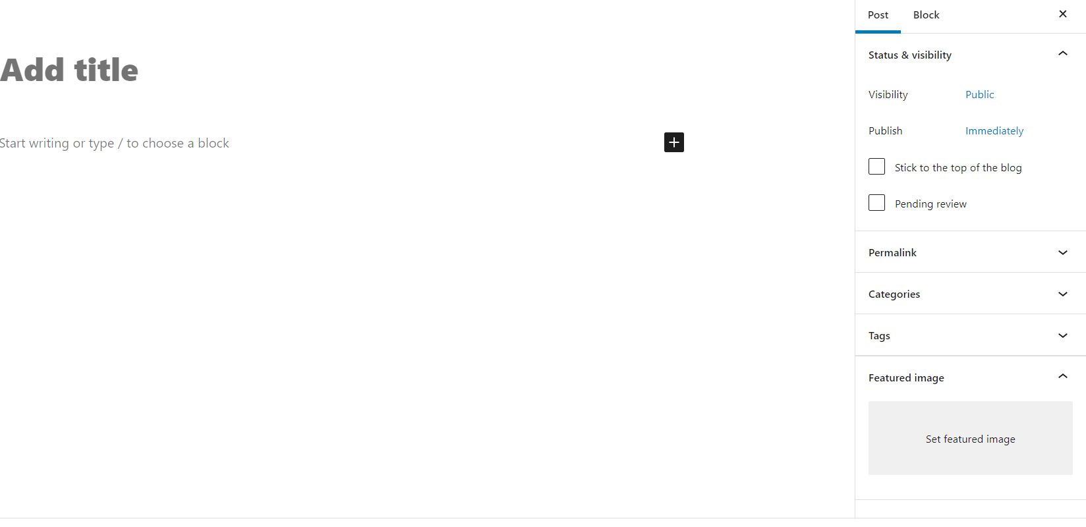

WORDPRESS provide us 3 by default option in the sidebar with the theme. These are themes, customize, theme editor.
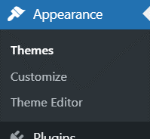
we can add more option in the sidebar. To add the widgets in the sidebar like menu, widgets first we have to register. To register we have to put the code in functions.php file. The code are
register_sidebar();
As we put this code in the function.php file. We automatically get two options widgets and menus
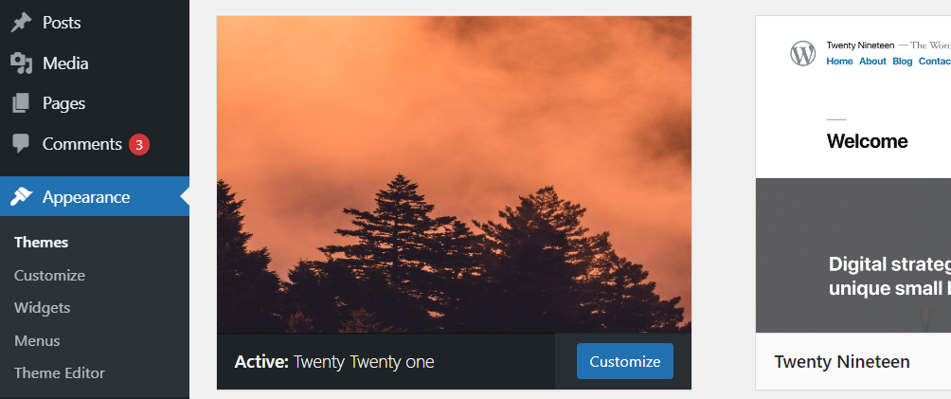

Now we can get sidebar from anywhere using get_sidebar functions
Note-
If you want to add the widget in the sidebar. Like this we put category in the sidebar. Then don’t make sidebar.php file neither it will ignore your widget and will execute the code written in the sidebar.php file

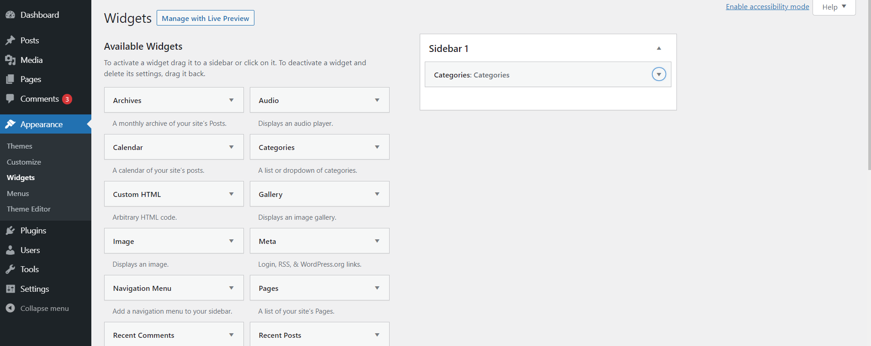

Theme for woocommmerce
If you want to develop the theme for woocommerce. Then you have to add this function in functions.php file.
add_theme_support(‘wocommerce’)

Register menu
If you want to register menu. Then we should use register_nav_menus($location) functions. We put the location in the array form like this.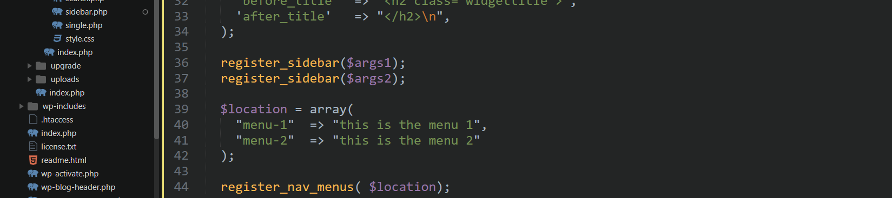

You can output like this in the menu which are in the appearance .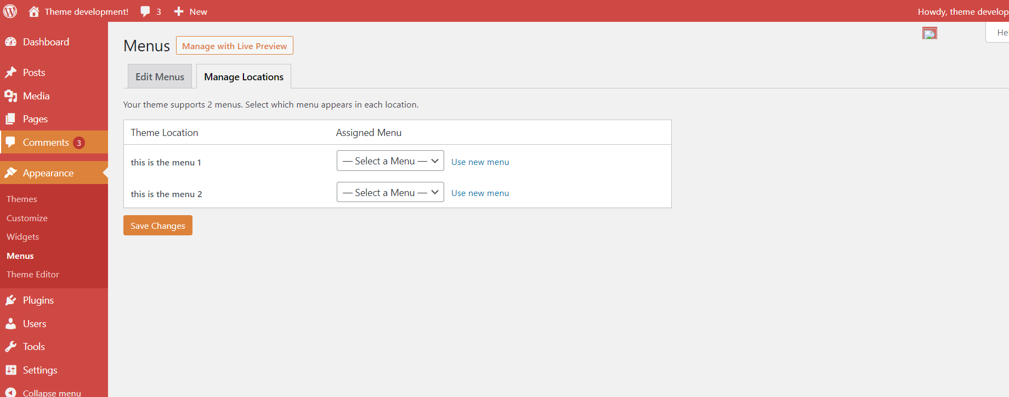

Hooks
hooks are basically check point
Two types of hooks available in wordpress
- filter hook
filter hook will return the data from the function

- action hook
action hook does not return anything

hooks functions
do_action()
it takes there args, first name of the hook, second function name of the hook third is priority of the hook. Remember 1 is the highest priority
remove_action
it is used to remove the hooks , it takes three parameters. First one is the name of hook second function name of hook and third one is priority of the hook,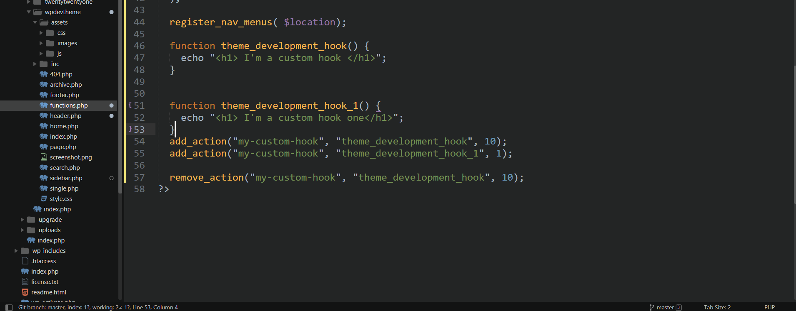

Four important functions
- get_template_directory() // this function work with the parent theme
- get_template_directory_uri() // this function will return the url of parent theme
- get_stylesheet_directory() // this function return the directory path from child theme
- get_stylesheet_directory_uri() // this function will return url of child theme
- get_stylesheet_uri();

WORDPRESS CSS standard
- Use tabs, not spaces, to indent each property.
- Add two blank lines between sections and one blank line between blocks in a section.
- Each selector should be on its own line, ending in either a comma or an opening curly brace. Property-value pairs should be on their own line, with one tab of indentation and an ending semicolon. The closing brace should be flush left, using the same level of indentation as the opening selector.

Correct:
1  2  3  4  5  6 | #selector-1,  #selector-2,  #selector-3 {  background: #fff;  color: #000;  }

Incorrect:
1  2  3  4  5  6 | #selector-1, #selector-2, #selector-3 {  background: #fff;  color: #000;  }  #selector-1 { background: #fff; color: #000; }

